**Detailed System Structure Models**

**Class Diagram:**

Below is the class diagram that have been created which is showing how the different function insides the classes are interacting with each other, that have been used throughout the project is interacting with each other. The class diagram below is showing how we have achieved the inheritance in our project.

**DublinBikesAPI, DublinBusAPI, IrishRailAPI, ParkingAPI, WeatherPollutionAPI, CityEventAPI.py**

In this class the code has been written which is responsible for getting the response for the request that have passed. The response for this is JSON file, CSV FILE, XML file which have been later pushed to the Database. In our project we have used the PostgresSql.

Uch a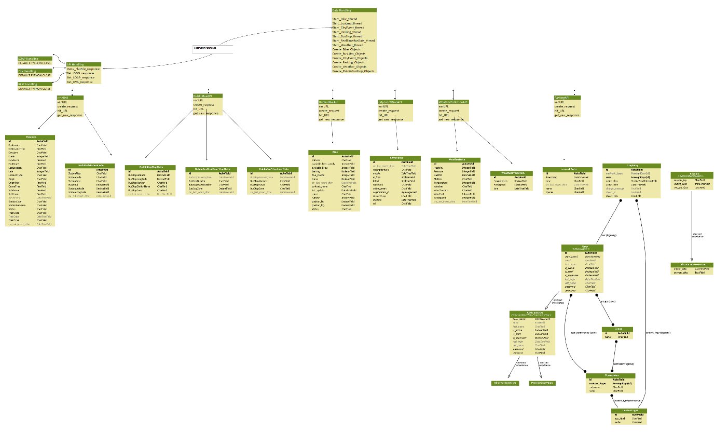

All the API handling classes are inheriting the different classes such as SOAP hanging, File Handling, Rest handling. This is shown in the above class diagram.

Classes IrishRailStationCode, DublinBusStopData, DublinRealTimeBusStopData, DublinBRealTimeData are inheriting the class DublinBusAPI. Object will be created which will help in storing the data in the database.

**Component Diagram:**

To show and understand how each of the python classes have interacting with another python file he below component diagram is drawn:

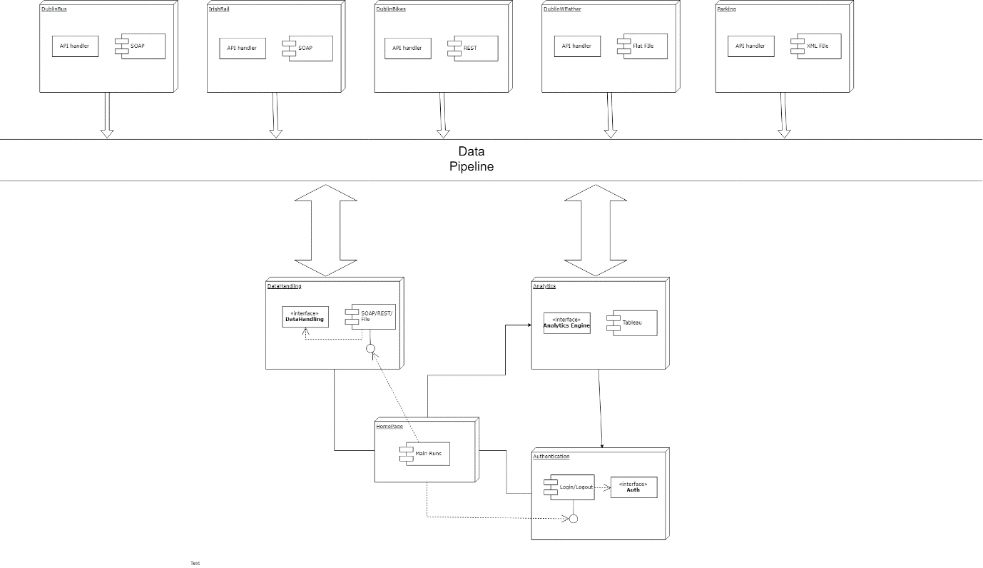

All the different classes that we have created are getting the data in various format. The data received is used for the analytics purposes. The class of user authentication will interact with the with the database classes to load the database in the DB.